Definitions of Solar System Configurations
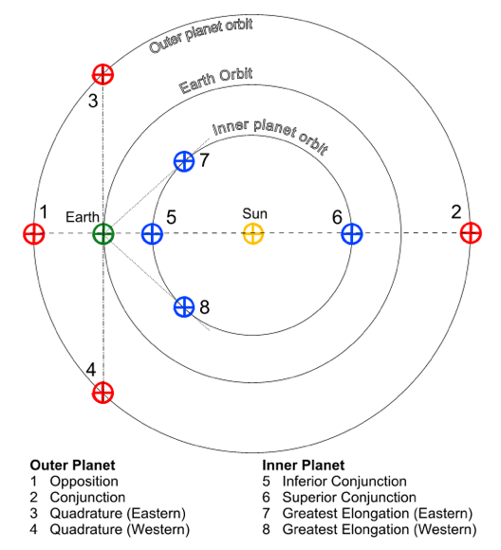

Elongation – The angular distance between the Sun and any other solar system body as seen from Earth. The greatest elongation of an inferior planet (inner planet relative to Earth) is its maximum angular distance from the Sun as seen from Earth.

Opposition – The position of a superior planet (outer planet relative to Earth) such that lies opposite the Sun in the sky as seen from Earth. Inferior planets can never appear in opposition to the Sun because their orbits lie inside that of Earth. Only superior planets can be seen in opposition to the Sun. (Elongation, ε, equals 180º.)

Conjunction – There are at least three definitions of conjunction – one for superior planets (called simply conjunction) and two for inferior planets (inferior and superior conjunction). Bodies are said to be in conjunction when they are seen in the same direction as the Sun. (Elongation, ε, equals approximately 0º.)

Inferior Conjunction The conjunction of an inferior planet when it appears between Earth and Sun. This configuration is called inferior conjunction because only inferior planets can demonstrate this type of conjunction.

Superior Conjunction – The conjunction of an inferior planet when it is in conjunction with the Sun but is located on the opposite side of the Sun as seen from Earth – just like superior planets when their elongations are approximately 0º.

Quadrature – The position of a body (Moon or planet) when its elongation is 90° west of the sun (visible in the morning sky) or 90º east of the sun (visible in the evening sky). The elongation at quadrature, the Sun-Earth-body angle, is 90°.

