Synodic and Sidereal Periods of Planets

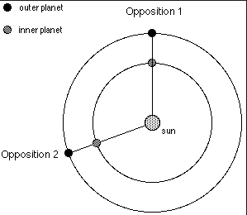
Nicholas Copernicus was able to work out the relationship between synodic periods (how long it takes an outer planet to go from opposition to opposition as seen from an inner planet) and synodic periods (how long it takes a planet to go 360 degrees around the sun) in the following manner.
From opposition 1 to opposition 2, the outer planet moves with a mean daily orbital motion of 360º/P_{o} where P_{o} is the sidereal period of the outer planet expressed in days. At the same time, the inner planet moves with a mean daily orbital motion of 360º/P_{i} where P_{i} is the sidereal period of the inner planet expressed in days. During the period of time from opposition 1 to opposition 2 the outer planet moves (360º/P_{o})(S) degrees where S – the synodic period – is expressed in days. During the same period, the inner planet moves (360º/P_{i})S degrees. If we subtract 360º degrees from the inner planet’s motion, we can equate the angles between the two successive oppositions.

By using this relationship, it is possible to determine the sidereal periods of all planets. By watching to see how long it takes a superior planet (one outside Earth’s orbit – Mars, Jupiter or Saturn) to move from opposition to opposition, one can determine its sidereal period. By watching to see how long it takes an inferior planet (one inside Earth’s orbit – Mercury or Venus) to move from one inferior conjunction to the next, one can determine its sidereal period. Use the above formula and the information about synodic periods below to determine the sidereal periods for each of the naked-eye planets.

Synodic Period (days) Sidereal Period (days = years)
Mercury 116
Venus 584
Earth ---- 365.25^{d} = 1.0^{yr}
Mars 780
Jupiter 399
Saturn 378

